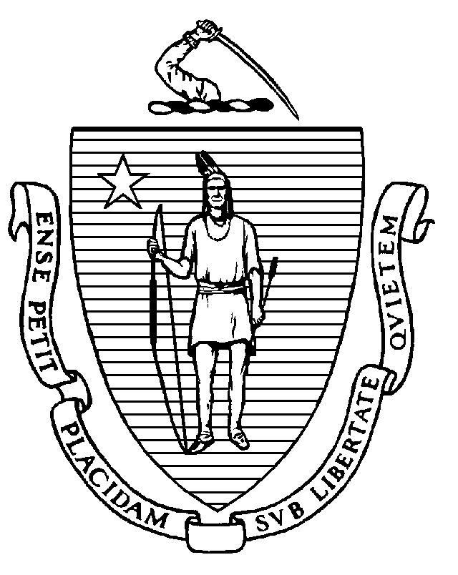
THE COMMONWEALTH OF MASSACHUSETTS

Executive Office of Environmental Affairs

DEPARTMENT OF FOOD AND AGRICULTURE
251 Causeway Street, Suite 500 Boston, MA. 02114-2151
617-626-1700 FAX 617-626-1850
JANE SWIFT
Governor

BOB DURAND
Secretary

Jonathan L. Healy.
Commissioner

NOTICE

PUBLIC HEARINGS: VEGETATION MANAGEMENT PLAN

Pursuant to the Rights-of-Way Management Regulations (333 CMR 11.00) in order to apply pesticides to control vegetation to maintain Rights-of Ways, the Department of Food and Agriculture must approve a Vegetation Management Plan (VMP) and a Yearly Operational Plan (YOP). The VMP is intended to justify the need to control vegetation, identify target vegetation, describe the intended methods of control, describe methods for identifying sensitive areas, describe operational guidelines for applicators, outline a program of Integrated Pest Management (IPM) designed to reduce the use of herbicides, and describe alternative land use activities.
The following community is advised that the City of Waltham proposes to utilize herbicides to treat their Rights-of-Way.

PUBLIC HEARINGS SCHEDULED:

In accordance with 333 CMR 11.05 the Department of Food and Agriculture will conduct a regional hearing to receive public comment on the proposed Vegetation Management Plan for the City of Waltham as submitted by: Mr. Arthur Mullin, Department of Public Works Foreman.

To provide all interested parties an opportunity to comment on the proposed VMP, a public hearing will be held at the following location:

Friday, April 12 from 10:30am until 1:00pm

Public Meeting Room, Government Center, 119 School Street, Waltham, Massachusetts

Plans Available for Public Review Prior to Hearings:

Section 11.05 (3)(d) of the ROW Management Regulations provide: “At least 21 days prior to the end of the public comment period, the applicant shall send a copy of the proposed VMP to the chief elected official, the Board of Health, and the Conservation Commission in affected communities upon their request.” Such request should be made to:

Mr. Arthur Mullin, Foreman
Department of Public Works
City of Waltham
167 Lexington Street
Waltham, MA 02451

Copies of the proposed VMP are also available for review at the Massachusetts Department of Food and Agriculture, Pesticide Bureau, during regular business hours. It is also available for review at the Reference Desk of the following public library:

Waltham Public Library, 735 Main Street, Waltham, Massachusetts

Written Comments Requested

The public hearings listed above will give interested parties the opportunity to present data, views or arguments, orally or in writing concerning the proposed VMP. Persons giving testimony are also requested to provide written comments. Written comments in advance of the hearing dates are welcome. The Department will accept written testimony concerning the City of Waltham’s VMP until the close of business: MONDAY, May 6, 2002.

Commentary should be sent to:

Rights-of -Way Program
Massachusetts Department of Food and Agriculture
251 Causeway Street, Suite 500
Boston, Massachusetts 02114-2151

